4.23 Shenzhen

Auto trading

1. Sizing

Sizing should depend on AM/PM/Overnight.

Last day crashed – eager to long

Last day big up – eager to short

Big premium – eager to short

Big discount – eager to long

AM open – conservative

Other AM – eager to short

PM – eager to long

Overnight – equal AM and PM.

Priority of determination of sizing

1. Premium and discount threshold checking.
2. AM PM checking

4.27

Weekly review:

Stocks: mtm: -10k

Futs: Mtm+25k

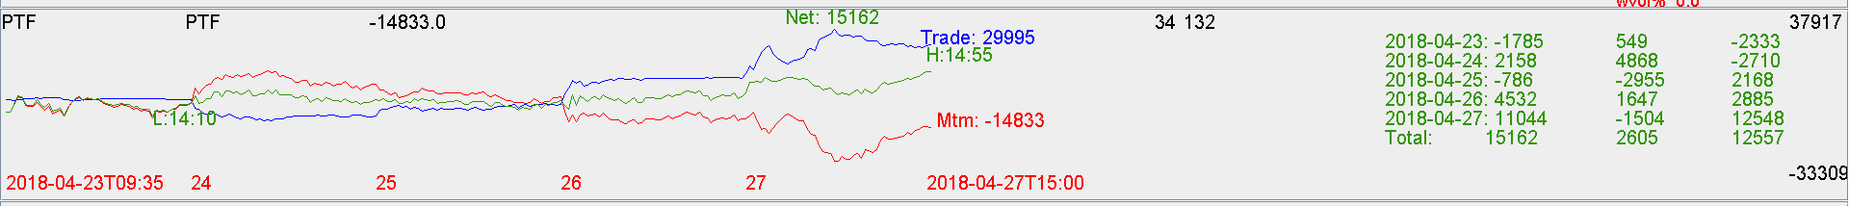

Keep working on auto trading.